7. Write a Servlet program to store a user's preferences (like theme or language) using cookies. Retrieve and display these preferences on
subsequent visits.

AIM
To develop a Java Servlet-based web application that stores user preferences (such as theme and language) using cookies and retrieves them on subsequent visits to personalize the weather information webpage.

ALGORITHM
- Create a Dynamic Web Project in Eclipse or any IDE.
- Add Servlet API library (Apache Tomcat server).
- Create an HTML form to accept user preferences: Theme (Light/Dark)
Language (English/Tamil/etc.)
- Develop a Servlet (PreferenceServlet): Read user inputs from the form.
Store preferences using cookies.
- Develop another Servlet (DisplayServlet): Retrieve cookies.
Display saved preferences along with weather info.
- Configure web.xml (if not using annotations).
- Run the project on server (Tomcat).

Test in browser:
First visit → set preferences.
Next visit → preferences auto-loaded.

SOURCE CODE

HTML Page (index.html)
<!DOCTYPE html>
<html>
<head>
<title>Event Booking</title>

<style>
body {
margin: 0;
font-family: 'Segoe UI', sans-serif;
background: linear-gradient(135deg, #1f1c2c, #928dab);
height: 100vh;
display: flex;
justify-content: center;
align-items: center;
}

.card {
backdrop-filter: blur(15px);
background: rgba(255,255,255,0.1);
padding: 30px;
width: 360px;
border-radius: 15px;
color: white;
box-shadow: 0 10px 30px rgba(0,0,0,0.3);
}

h2 {
text-align: center;
margin-bottom: 20px;
}

label {
font-size: 14px;
}

select {
width: 100%;
padding: 10px;
margin: 8px 0 15px;
border-radius: 8px;
border: none;
outline: none;
}

input[type="submit"] {
width: 100%;
padding: 12px;
background: #ff7a18;
border: none;
border-radius: 8px;
color: white;
font-size: 15px;
cursor: pointer;
transition: 0.3s;
}

input[type="submit"]:hover {
background: #ff512f;
}

a {
display: block;
text-align: center;
margin-top: 15px;
color: #ffd369;
text-decoration: none;
}
</style>
</head>

<body>

<div class="card">
<h2>Event Booking</h2>

<form action="PreferenceServlet" method="post">

<label>Theme</label>
<select name="theme">
<option value="Light">Light</option>
<option value="Dark">Dark</option>
</select>

<label>Language</label>
<select name="language">
<option value="English">English</option>
<option value="Tamil">Tamil</option>
<option value="Hindi">Hindi</option>
</select>

<label>Category</label>
<select name="category">
<option value="Concert">Concert</option>
<option value="Sports">Sports</option>
<option value="Theater">Theater</option>
<option value="Comedy">Comedy</option>
</select>

<input type="submit" value="Save Preferences">
</form>

<a href="DisplayServlet">View Events</a>
</div>

</body>
</html>

PreferenceServlet.java
package com.example.main.java.com.example;
import java.io.*;
import javax.servlet.*;
import javax.servlet.http.*;
import javax.servlet.annotation.WebServlet;

@WebServlet("/PreferenceServlet")
public class PreferenceServlet extends HttpServlet {

private static final long serialVersionUID = 1L;

protected void doPost(HttpServletRequest request, HttpServletResponse response)
throws ServletException, IOException {

String theme = request.getParameter("theme");
String language = request.getParameter("language");
String category = request.getParameter("category");

Cookie c1 = new Cookie("theme", theme);
Cookie c2 = new Cookie("language", language);
Cookie c3 = new Cookie("category", category);

c1.setMaxAge(86400);
c2.setMaxAge(86400);
c3.setMaxAge(86400);

response.addCookie(c1);
response.addCookie(c2);
response.addCookie(c3);

response.setContentType("text/html");
PrintWriter out = response.getWriter();

out.println("<html><head><style>");
out.println("body{background:#667eea;display:flex;justify-content:center;align-items:center;height:100vh;font-family:'Segoe UI';}");
out.println(".box{background:white;padding:25px;border-radius:10px;width:350px;text-align:center;}");
out.println(".info p{background:#f1f3f6;padding:10px;border-radius:6px;margin:8px 0;}");
out.println("a{display:inline-block;margin-top:15px;padding:10px;background:#4a69bd;color:white;text-decoration:none;border-radius:6px;}");
out.println("</style></head><body>");

out.println("<div class='box'>");
out.println("<h2>Preferences Saved</h2>");

out.println("<div class='info'>");
out.println("<p><b>Theme:</b> " + theme + "</p>");
out.println("<p><b>Language:</b> " + language + "</p>");
out.println("<p><b>Category:</b> " + category + "</p>");
out.println("</div>");

out.println("<a href='DisplayServlet'>View Events</a>");
out.println("</div>");

out.println("</body></html>");
}
}

DisplayServlet.java
package com.example.main.java.com.example;

import java.io.*;
import javax.servlet.*;
import javax.servlet.http.*;
import javax.servlet.annotation.WebServlet;

@WebServlet("/DisplayServlet")
public class DisplayServlet extends HttpServlet {

private static final long serialVersionUID = 1L;

protected void doGet(HttpServletRequest request, HttpServletResponse response)
throws ServletException, IOException {

Cookie[] cookies = request.getCookies();

String theme = "Not Set";
String language = "Not Set";
String category = "Not Set";

if (cookies != null) {
for (Cookie c : cookies) {
if ("theme".equals(c.getName())) theme = c.getValue();
if ("language".equals(c.getName())) language = c.getValue();
if ("category".equals(c.getName())) category = c.getValue();
}
}

response.setContentType("text/html");
PrintWriter out = response.getWriter();

out.println("<html><head><style>");
out.println("*{margin:0;padding:0;box-sizing:border-box;font-family:'Segoe UI';}");
out.println("body{background:#f4f6f9;display:flex;justify-content:center;align-items:center;height:100vh;}");
out.println(".container{width:420px;background:white;padding:25px;border-radius:12px;box-shadow:0 8px 20px rgba(0,0,0,0.1);}");
out.println("h2{text-align:center;margin-bottom:15px;color:#333;}");
out.println(".info p{background:#f1f3f6;padding:10px;border-radius:6px;margin:6px 0;}");
out.println("table{width:100%;border-collapse:collapse;margin-top:10px;}");
out.println("th{background:#4a69bd;color:white;padding:10px;}");
out.println("td{padding:10px;text-align:center;border-bottom:1px solid #ddd;}");
out.println("tr:hover{background:#f9f9f9;}");
out.println(".btn{display:block;text-align:center;margin-top:15px;padding:10px;background:#4a69bd;color:white;text-decoration:none;border-radius:6px;}");
out.println("</style></head><body>");

out.println("<div class='container'>");
out.println("<h2>Event Details</h2>");

out.println("<div class='info'>");
out.println("<p><b>Theme:</b> " + theme + "</p>");
out.println("<p><b>Language:</b> " + language + "</p>");
out.println("<p><b>Category:</b> " + category + "</p>");
out.println("</div>");

out.println("<table>");
out.println("<tr><th>Event</th><th>Venue</th></tr>");

if (category.equals("Concert")) {
out.println("<tr><td>AR Rahman Live</td><td>Chennai</td></tr>");
} else if (category.equals("Sports")) {
out.println("<tr><td>CSK vs MI</td><td>Chepauk</td></tr>");
} else if (category.equals("Theater")) {
out.println("<tr><td>Drama Show</td><td>Music Academy</td></tr>");
} else if (category.equals("Comedy")) {
out.println("<tr><td>Stand-up Show</td><td>Mall</td></tr>");
} else {
out.println("<tr><td colspan='2'>No Events</td></tr>");
}

out.println("</table>");
out.println("<a href='index.html' class='btn'>Back</a>");
out.println("</div>");

out.println("</body></html>");
}
}
web.xml
<web-app>
<servlet>
<servlet-name>PreferenceServlet</servlet-name>
<servlet-class>PreferenceServlet</servlet-class>
</servlet>
<servlet-mapping>
<servlet-name>PreferenceServlet</servlet-name>
<url-pattern>/PreferenceServlet</url-pattern>
</servlet-mapping>
<servlet>
<servlet-name>DisplayServlet</servlet-name>
<servlet-class>DisplayServlet</servlet-class>
</servlet>

<servlet-mapping>
<servlet-name>DisplayServlet</servlet-name>
<url-pattern>/DisplayServlet</url-pattern>
</servlet-mapping>
</web-app>

OUTPUT :

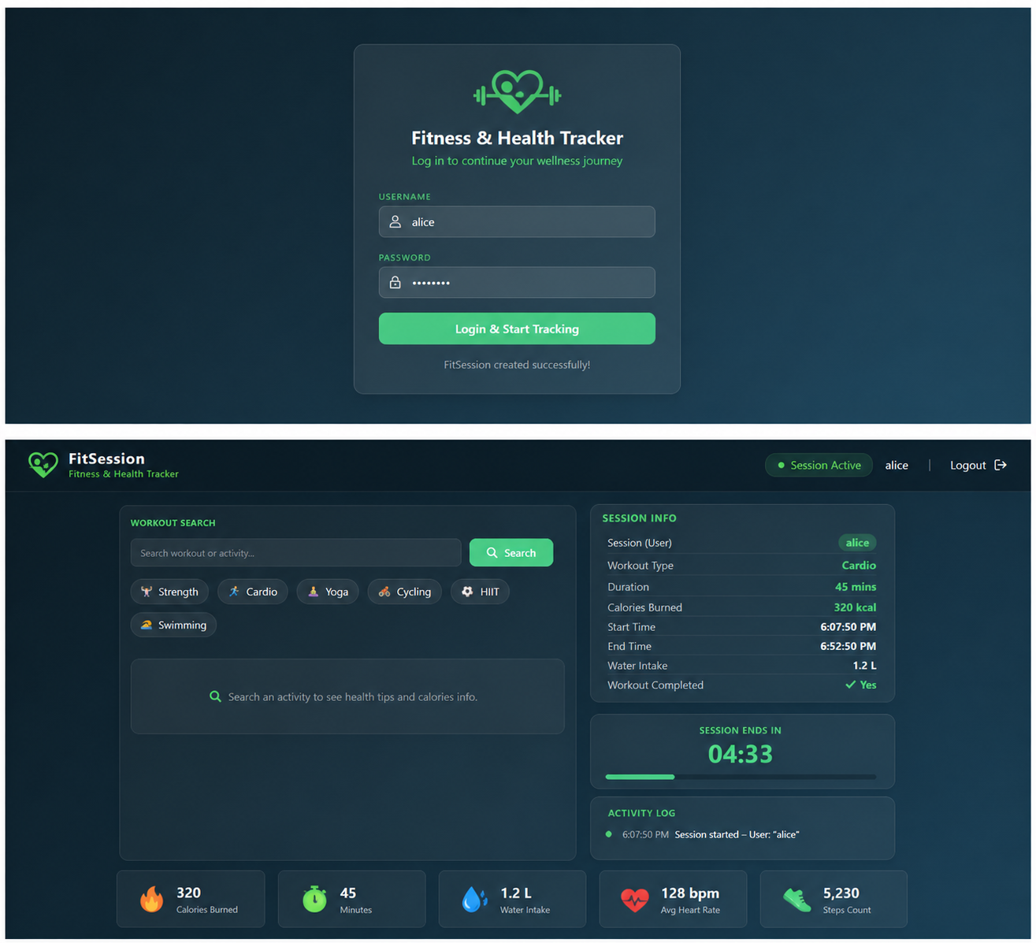

Result:
The experiment was successfully completed.User preferences (theme and language) were stored using cookies and retrieved on subsequent visits, allowing the weather webpage to provide a personalized user experience.

